Measuring the field of view (FOV)

* The field of view is the circular area under observation when using a microscope.
* You need to know the diameter of the field of view to calculate the size of the specimen you are looking at.
* All you need to calculate the field diameter is a slide with a millimetre grid or ruler mounted on it.

The microscope you will be using has three different magnifications, these are 40x, 100x, 400x this is calculated by multiplying the eyepiece lens (10x) by the objective lens (4x, 10x and 40x).

Method:

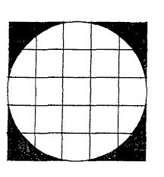PART 1 – Calculating Field of View

1. Place the slide with a minigrid on the stage.
2. Focus the microscope on low power. Make sure one of the lines of the minigrid lines up with the outer edge of the view.
3. Count the amount of boxes that fit across the microscope
4. Each one of these boxes represents 1mm.
5. Fill in the following information for **low power**

|  |  |
| --- | --- |
| Magnification | Amount of boxes |
|  |  |

1. Repeat the steps for the **Medium power**

|  |  |
| --- | --- |
| Magnification | Amount of boxes |
|  |  |

1. Repeat again for the high power (be careful not to use the coarse adjustment knob)

|  |  |
| --- | --- |
| Magnification | Amount of boxes |
|  |  |

1. Fill in the table below with all the information

|  |  |  |
| --- | --- | --- |
| Magnification | Amount of boxes | Field of view (mm) |
| 40x |  |  |
| 100x |  |  |
| 400x |  |  |

Part 2 – Using FOV to estimate cell size

Method

1. Place the minigrid slide on the stage
2. Focus your microscope on the ‘e’ on low power
3. Estimate how many ‘e’s would fit across the field of view
4. Fill out the table below with the results

|  |  |
| --- | --- |
| FOV | Number of ‘e’s that fit |
|  |  |

1. To work out he approximate size of the letter ‘e’ we must divide the number of ‘e’s that fit by the FOV.

|  |  |  |
| --- | --- | --- |
| FOV | Number of ‘e’s that fit | FOV / number ‘e’s |
|  |  |  |

1. For example, if I had a field of view of 10mm and 2.5 ‘e’s fit across the I would divide 10 by 2.5 to get 4. The estimated size of the cell is 4mm.
2. Pack away your microscope and return your slides.

PART 3

Practice Questions

1. Calculate the Field of View of the following images (each box is 1mm)

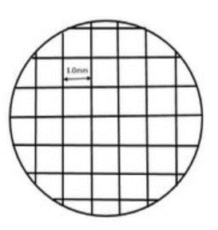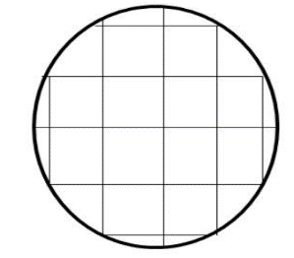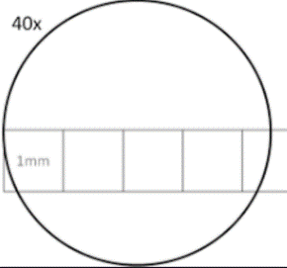

FOV = FOV = FOV =

1. Aaron was looking three different slides through a microscope with a field of view of 2mm. He noticed that on the first slide that 2 cells fit across the FOV. Calculate the size of each cell (FOV divided by number of cells)
2. Aaron’s second slide could fit 12 cells across. Calculate the size of each cell.
3. The final slide looked like this. Calculate the size of the cells.

